Clarity Call Center Agent User Dashboard Guide
_____________________________________________________________________________

This guide includes:
- Logging into the Portal
- Changing User Profile, Password, and Voicemail PIN
- Going Online / Offline
- Messaging:
  - Voicemail
  - Portal Chat
  - SMS/MMS
- Adding Contacts in the Portal
- Using “Click-to-Call” for outbound calls from
  - Contact List
  - Call History
  - Dial Pad
- Answering Rules
- Changing Outbound Caller ID

Logging in to the Portal
1. Navigate to: portal.clarityvoice.com to log in.
(For Portal login outside of first use, skip to step 8)
NOTE: It is recommended that you use the latest version of Google Chrome for optimal use.
2. Select ‘Are you a new User?” below the window
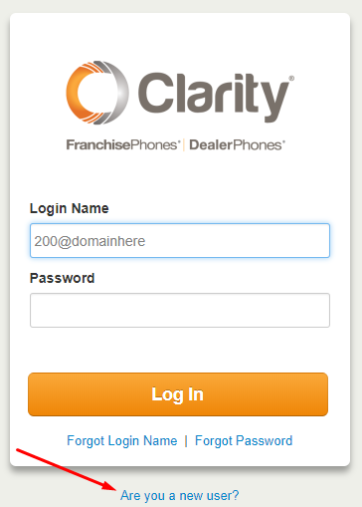
3. Use the email address that your Installer or Organization Manager has added to your User Profile, and the Extension if you have been given it.
4. Click ‘Send’ and a Welcome Email will be sent.
5. Open the Welcome Email and click ‘Complete Setup’.
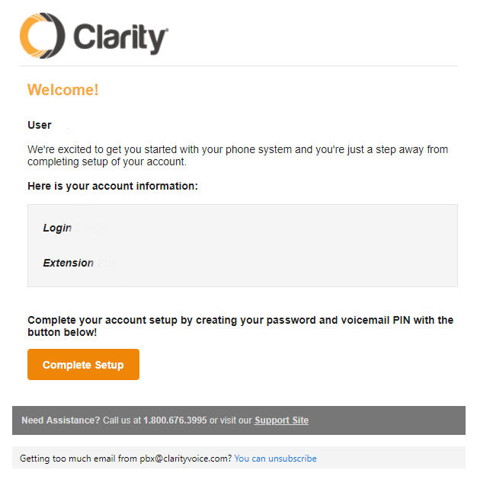
6. You’ll be taken to the New User Credentials screen (below) and here will select your New Password (minimum 8 characters, must include at least 1 capital letter and at least 1 number. You can also select a 4-digit Voicemail PIN, or feel free to use the default 4321
7. Click Save & log out.
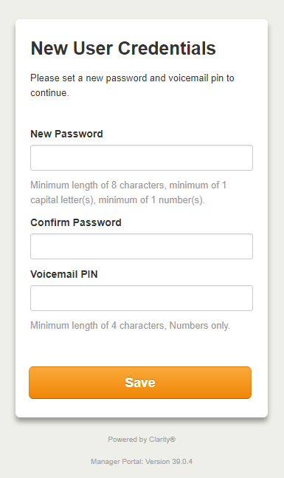
8. Navigate to: portal.clarityvoice.com to login. You’ll need to use your Username in the format ###@domain (example: 239@clarity) with the Password you’ve created. This is how you will need to log in each time after the initial time.

Changing User Profile, Password or Voicemail PIN
1. When you log in you will see the home screen below. To change your settings, click on User ### (###) in the upper right corner and select profile.
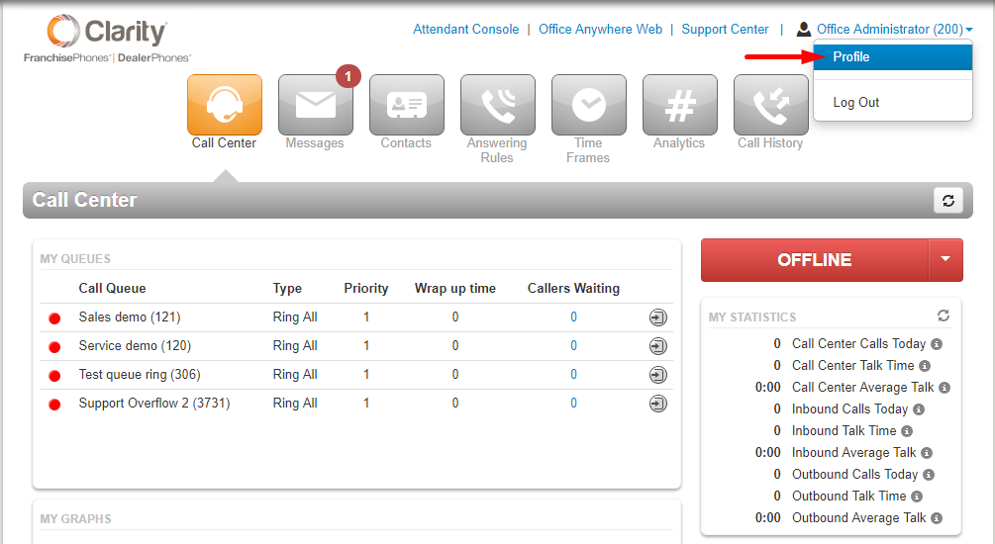
2. In the menu below you can change User Name, Directory Options, Password or Voicemail PIN (scroll to bottom to select a new PIN if desired)
The default Voicemail PIN is 4321.
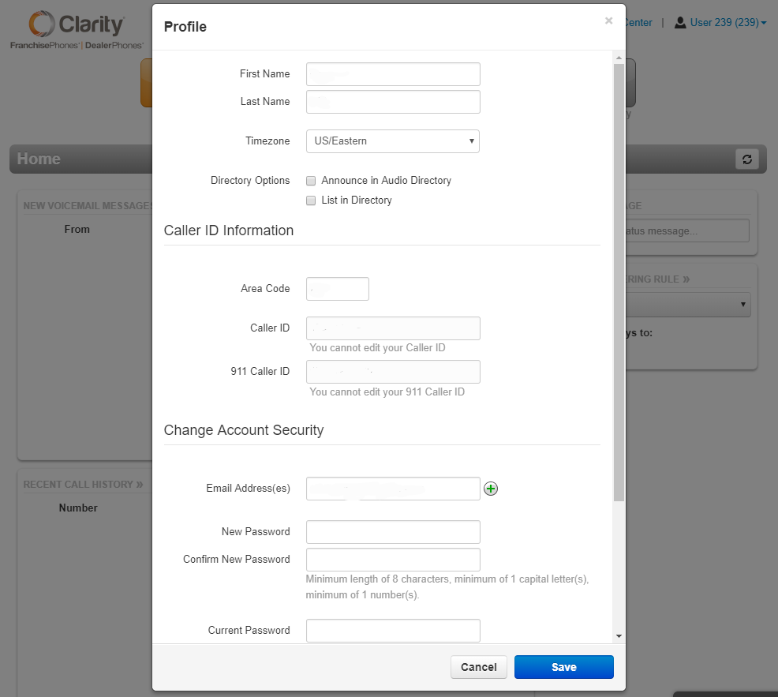
NOTE: You cannot change the Caller ID settings.
3. Always be sure to click Save when changing settings in the Portal.

Call Center / Going “Online” or “Offline”
- My Queues – Call Queues you are assigned to will display here
- When you arrive at the home screen, you will see a button that either says “Online” or “Offline.”
You can toggle between the two.
•Online = you are logged into the call queues and incoming calls that hit the queue will ring your phone.
•Offline = you are logged out of all call queues and will not receive incoming calls that ring into the call queue.

- My Statistics
- Active Phones - the designation(s) on the device(s) you are currently using)
- Recent Call History

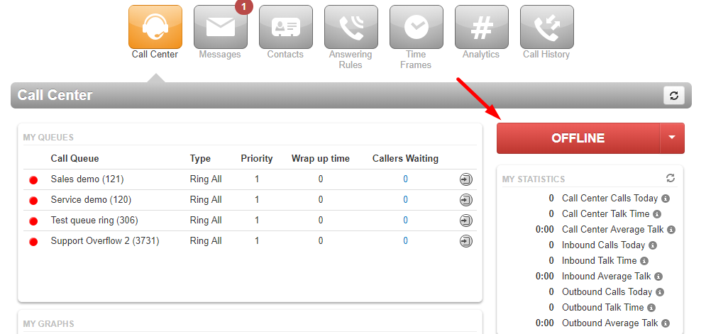

MESSAGING: VOICEMAIL, CHAT & SMS/MMS
Messaging: Accessing & Managing Your Voicemail
- Click on the Messages button
- The first tab you will be brought to is your Voicemail list. Here you can access New, Saved and for a short time Trash.
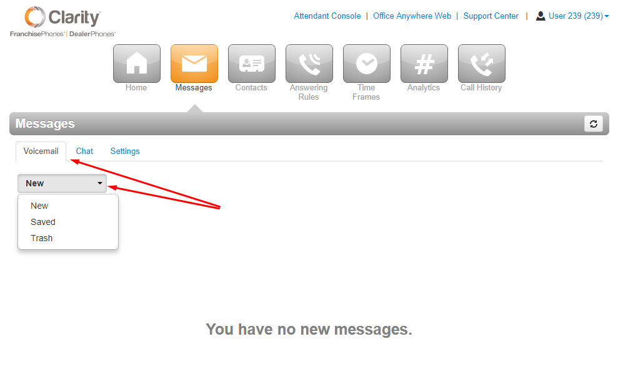

Messaging: Managing Your Voicemail Greeting and Other Settings
- Click on Settings
- The window below displays the Voicemail Settings tab. There will be a generic message by default, but if you wish to record a new Voicemail greeting click on Manage (as seen below) in the Greetings section.
NOTE: The options for putting a new Recorded Name work the same as Voicemail Greeting.
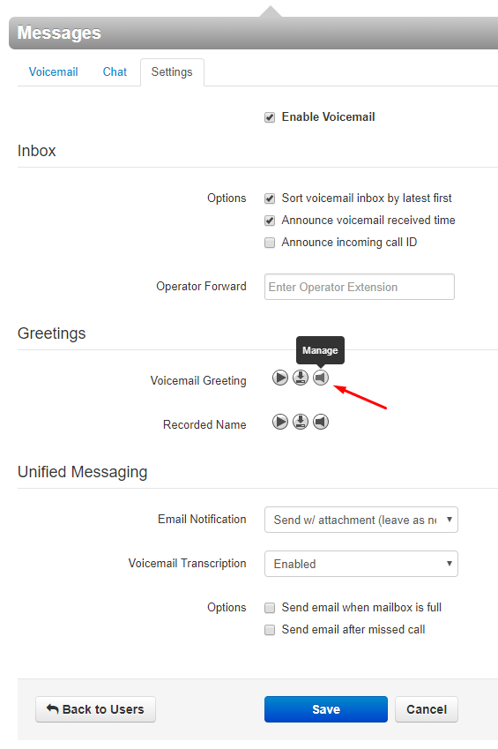
- You have the option to Name and then Upload a pre-recorded greeting or
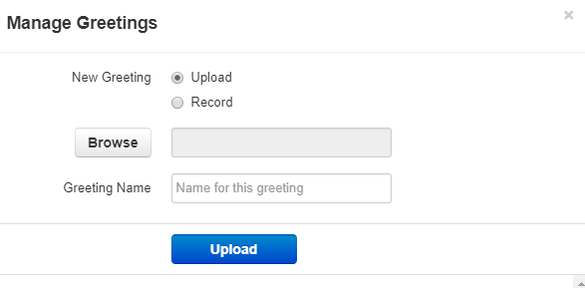
- You may Name and Record a greeting by having the automated system call you at an extension or external telephone number. To record your greeting from a cell or other outside phone please input the 1+number 11 digits without hyphens or apostrophes.
- Click Call
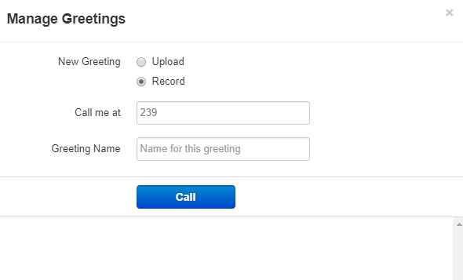
- You may have several voicemail greetings loaded for different occasions and change the active one through this menu.
- UNIFIED MESSAGING offers you the ability to receive Email or Text notifications when Voicemails are left on in your mailbox, when you have missed a call, and when your voicemail box is full.
- Emails will be sent to any email address on your Profile. To include a text to cell phone, please contact Clarity Support with the phone number and name of the carrier.
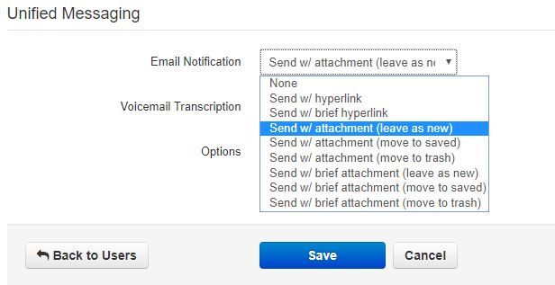
- Email notification offers several options, as seen above. Select the one that best suits your needs.
- Remember to click Save when done selecting your settings.

MESSAGES: Accessing the Chat Features
- To Chat others within your domain, select the Chat tab
- To begin a new Chat, click on the orange New Conversation button
- The pop-up window will appear
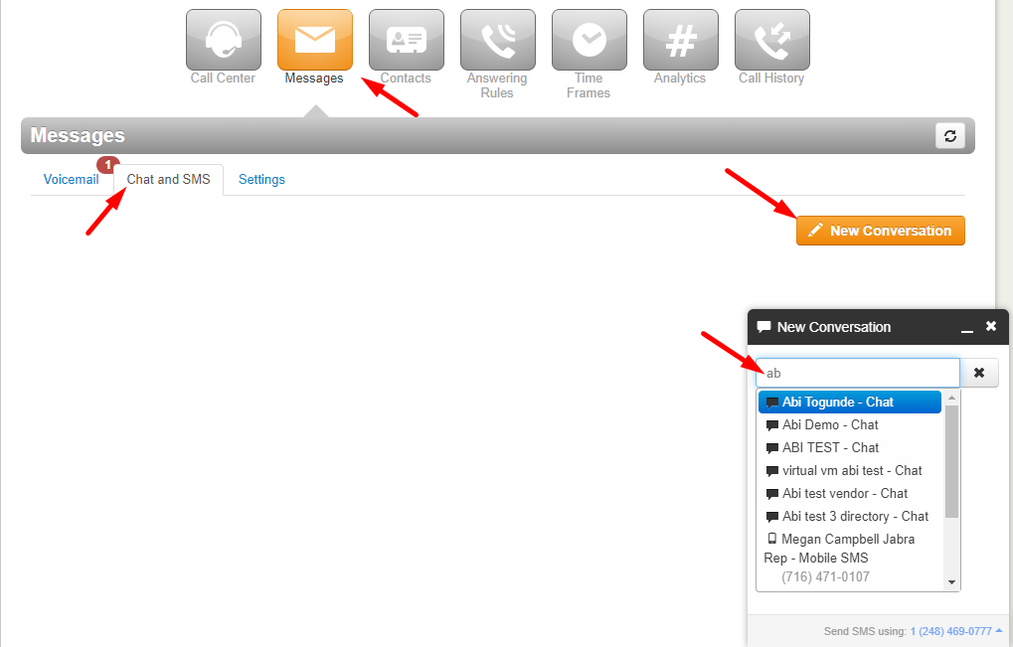
- Once you input the contact the New Conversation window will change, and give you options to
  - Chat
  - Video Conferencing
  - Click-to-Call
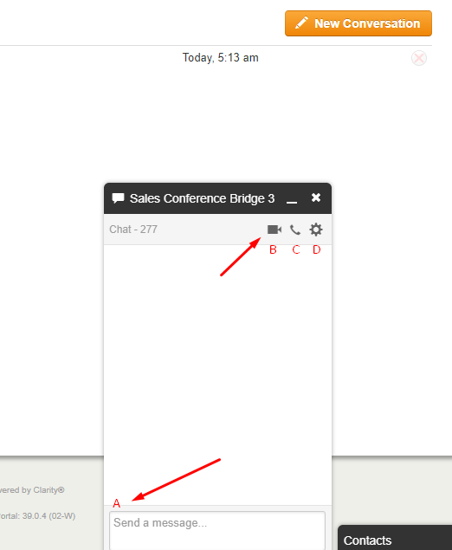
  - Access Settings – Turn Notifications On/Off, or Delete Conversation
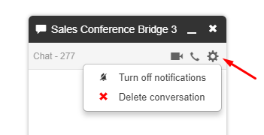

MESSAGING: SMS/MMS aka “Texting”
- Clarity Voice offers SMS (text) and MMS (picture) messaging through the Portal.
- The SMS/MMS controls for each number on the domain can only be assigned to one User in the domain. Users may be assigned multiple numbers on the domain, but multiple Users may not access messaging for 1 number on the account.
- To access SMS/MMS features click on Messages.
- If your User is assigned control of an SMS/MMS number, the tabs under Messages will read
  - Voicemail
  - Chat and SMS
  - Settings
  - Click on Chat and SMS
- Select a current messaging thread from the list OR click on the orange New Conversation button to send a message.
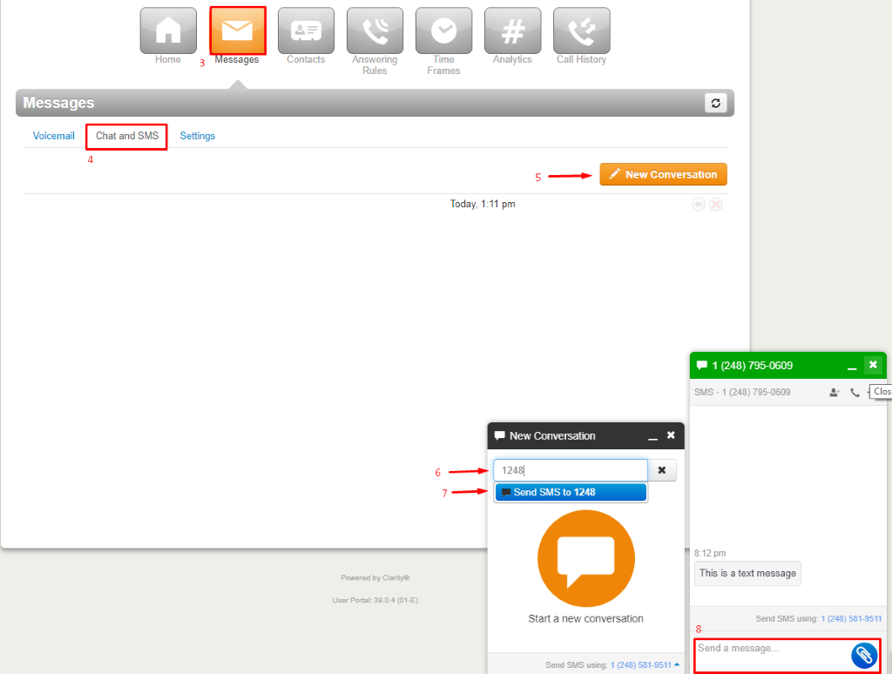
- Input the 11-digit number (1xxxxxxxxxx) or contact from your list.
- Click Send to (selected number or User) highlighted in blue below the text window.
- The pop-up will change to show a text box (for text) and a blue button with a paperclip icon (to attach images).
NOTE: Inbound SMS conversation has the green header.
- Once you have completed the message simply press the Enter key and it will send your message.

Adding Contacts to Portal
- Click on “Contacts”
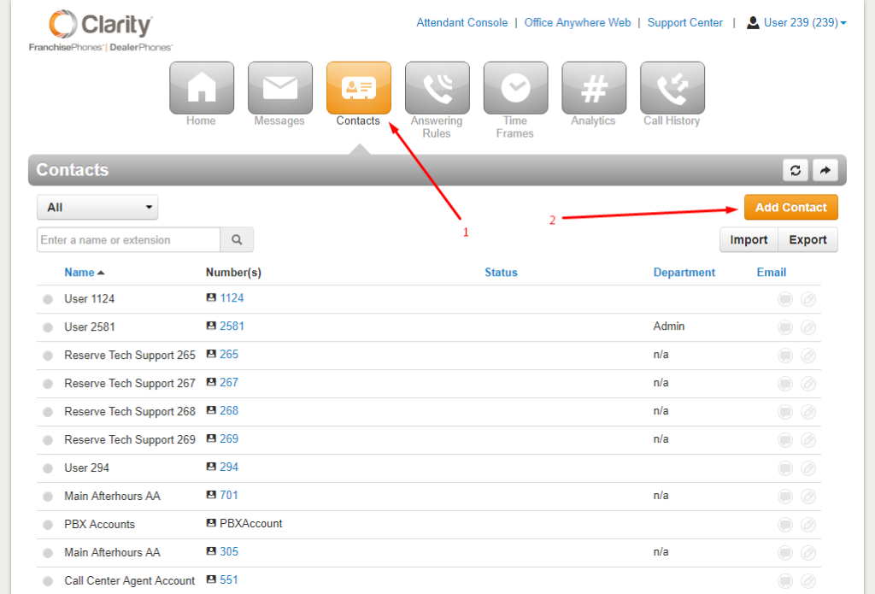
- Select the orange Add Contact button
- Enter in the contact information:
When entering the number, make sure it’s in the following format: 1xxxxxxxxxx (without dashes, spaces, or special characters)
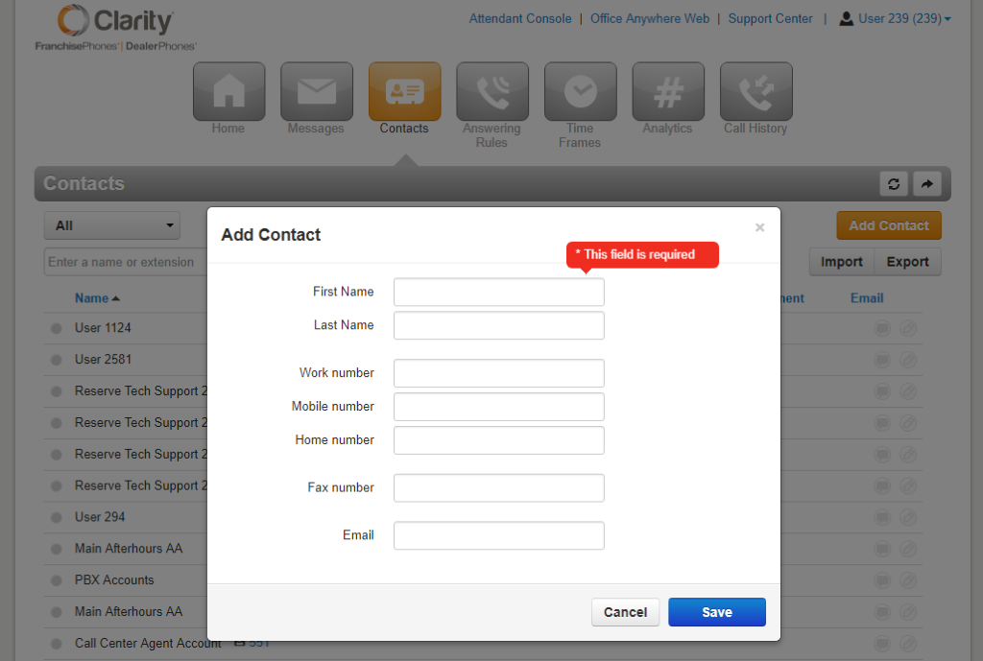
- If you have a Contact List you prefer to upload, select Import and upload the Outlook csv, or the Google file, or Apple Vcard file.
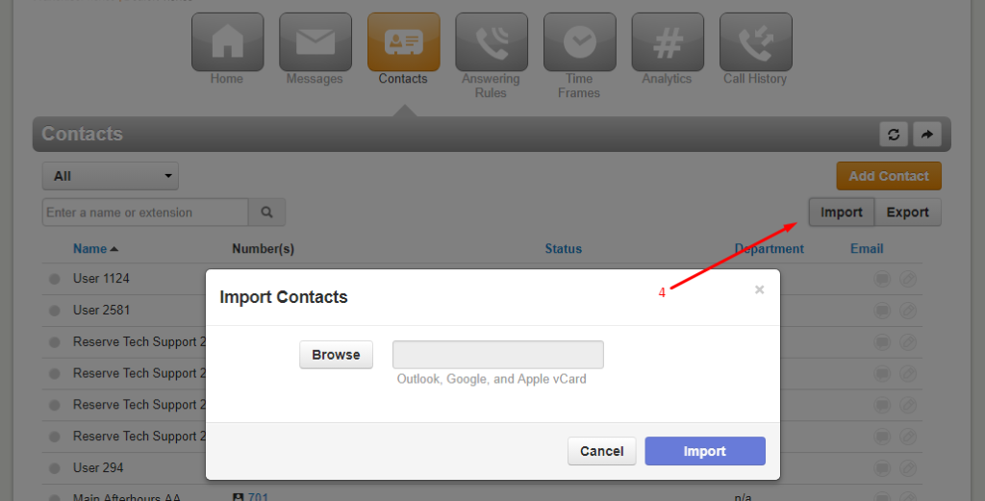

Using “Click-to-Call” for Outbound Calls
• The Clarity Portal allows you to make outbound calls from your Contact List, Dial Pad, or even your Call History.
Calling from Contact List
- Click on the Contacts tab on the top of your screen
- Next to each contact you’ll find a link with their telephone number or extension. Click on the number and a small box will pop up with the options Call or Cancel
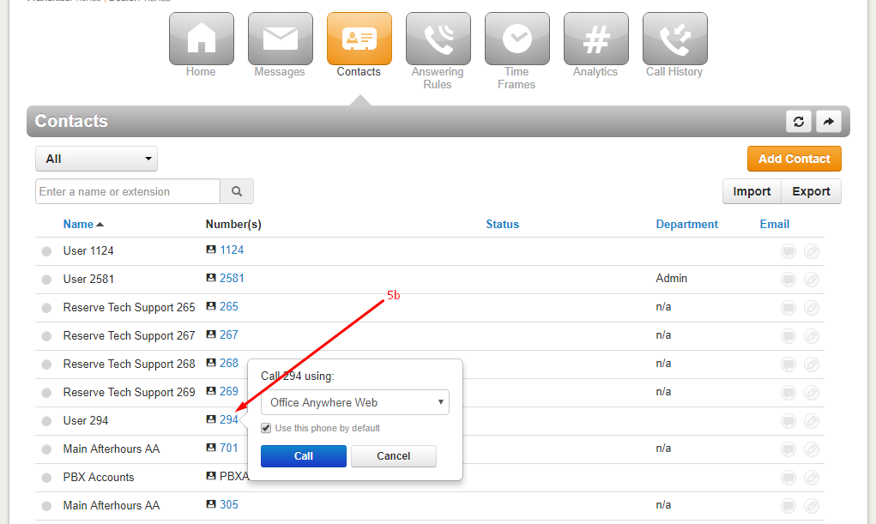

Calling from Call History
- Select the range of dates you’d like to search, or leave it as is for today’s date. NOTE: The maximum range of dates you can search is 31 days. Most Call History will go back 1 year but must be searched in 31-day increments.
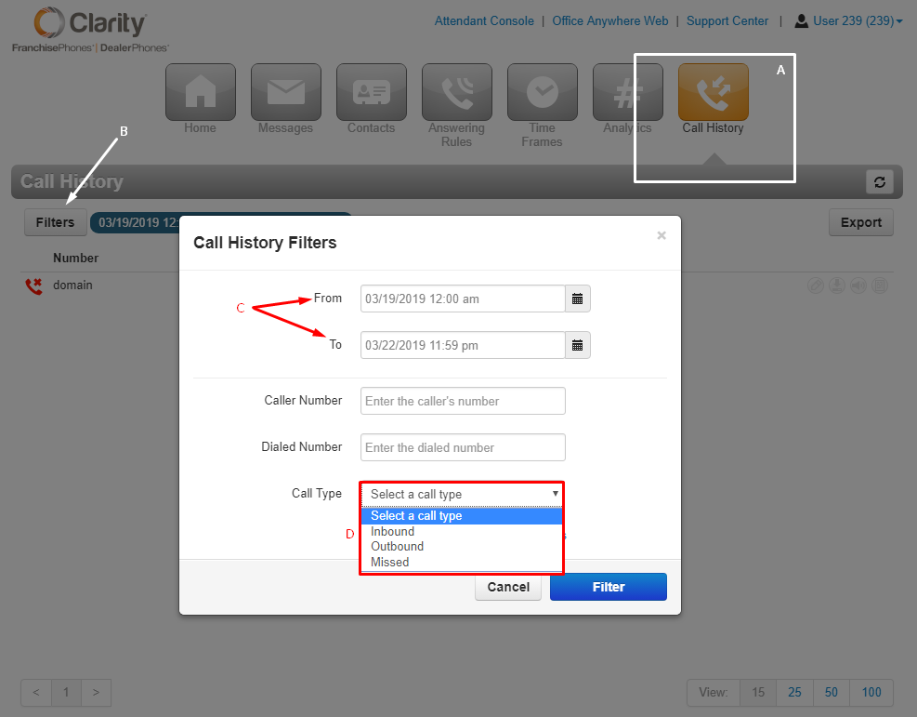
- Select the drop down next to Call Type and choose one of the following:
• Inbound (incoming calls)
• Outbound (outgoing calls that you’ve made)
• Missed (Calls that were missed/unanswered by you)
- Click to Call
  - If you would like to call any of the numbers, just click on the blue link with the telephone number and press the blue Call button
    - a. You’ll have the option to call with your phone (default), an external cell phone, or Office Anywhere Web. Your office phone will be the default.
    - b. If you choose a cell number, input it with the format: 1xxxxxxxxxx (no spaces or special characters)
    - c. For more on Office Anywhere Web, see that section.
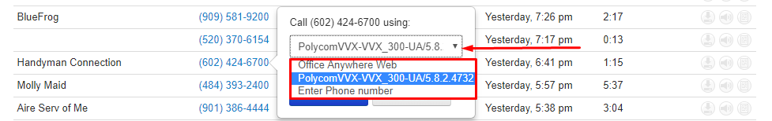
  - Your chosen phone will begin to ring.
  - Answer your phone and the call will immediately begin ringing to the chosen number.

Calling with the Dial Pad
1. On the bottom of the screen you should see the black pop up “contact” list
2. Click on the Contacts pop up list
3. At the top of your list you will see your name. To the right of your name there is an icon of a phone.
4. Click on the phone icon
5. A dial pad will pop up to the left of the contact list. Here you can type, paste, or dial any number and press Call afterwards.
6. Once you press Call, the phone will ring your extension and you will need to answer. Once you answer, the call will ring out to the number you entered in the dial pad.

Answering Rules
• Once you’ve created your Time Frame you can now create your Answering Rule.
• The Answering Rule tab allows you to create, order, edit individual answering rules. It is also the section where you can change the Ring time.
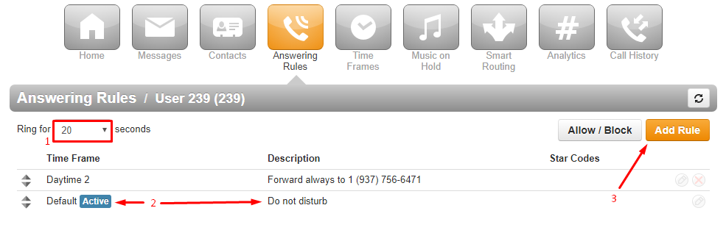
- The Ring for [_] seconds option allows you to adjust the ring time or number of rings (Average 1 ring per 5 seconds).
- The highest rule on the list (top to bottom) with an active Time Frame will show the blue Active indicator.
- Click on Add Rule to create a new Answering Rule for the User extension.
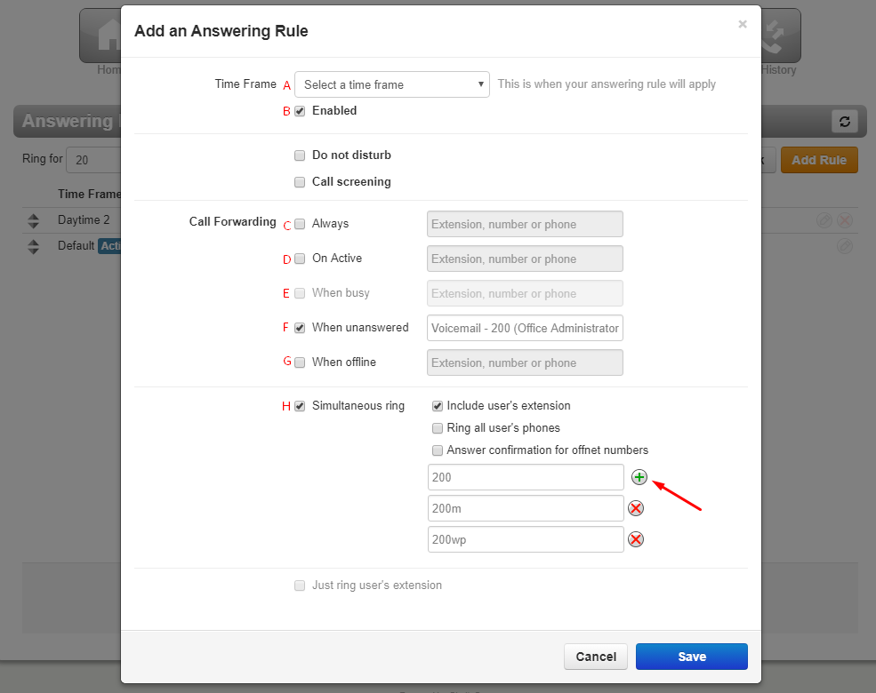
  - Time Frame that will dictate whether this Answering Rule is active or inactive.
  - Enabled or when unchecked - Disabled (will not work during active Time Frame)
  - Always – use this option for 1 device
  - On Active – determines what happens if you are on an active call.
  - When Busy – You do not need to use this feature.
  - When Unanswered – Calls unanswered by the ‘Always’ or ‘Simultaneous ring’ devices/numbers will then follow the rule here. Typically, the voicemail or the number of an answering service.
  - When Offline – Determines what happens to calls when the system is not registering to our server. Typically used for the voicemail or answering service number.
  - Simultaneous Ring – Allows calls to User to ring multiple devices. To add more devices, click on the ‘+’ for another text box to add the device’s designation or an outside number (use the format: 1xxxxxxxxxx with no special cases or spaces).

NOTE: Simultaneous ring + ‘Answer confirmation for offnet numbers’ will allow calls unanswered by outside cell phones to use the ‘When Unanswered’ (f) rule. The ‘Answer confirmation...’ will prompt the recipient to press 1 to accept the call, and if 1 is not pressed the call will return to the system.

Changing Outbound Caller ID
- Click on User ### (###) in the upper right corner.
- Select Profile.
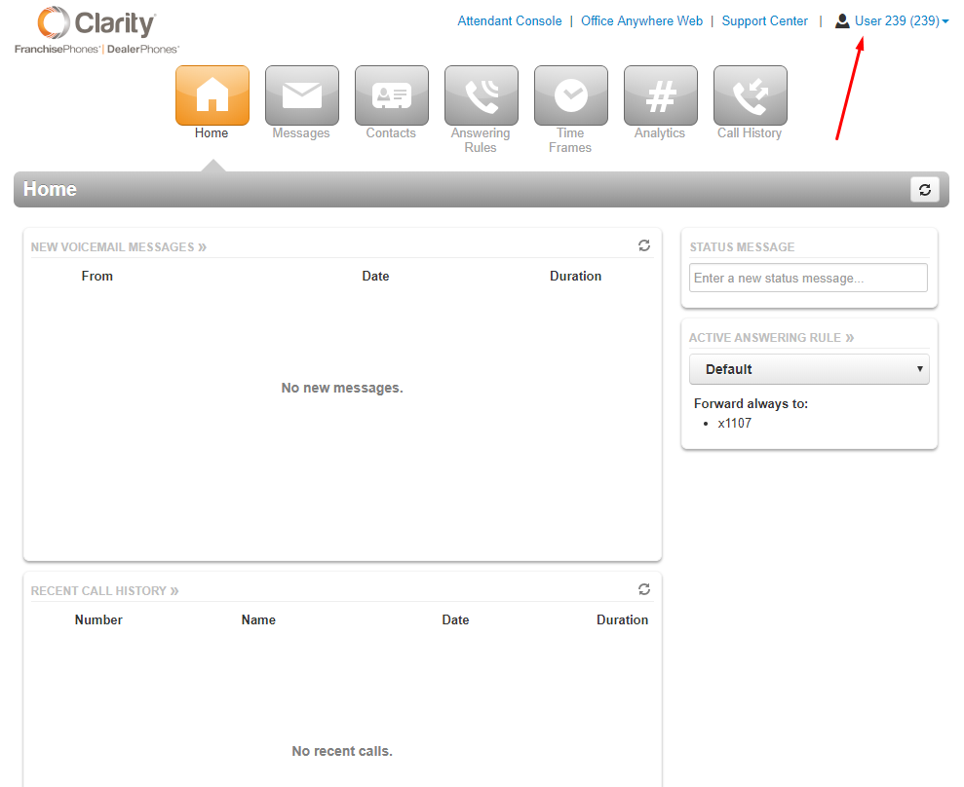
- Select the Caller ID number you need from the drop-down Caller ID menu.
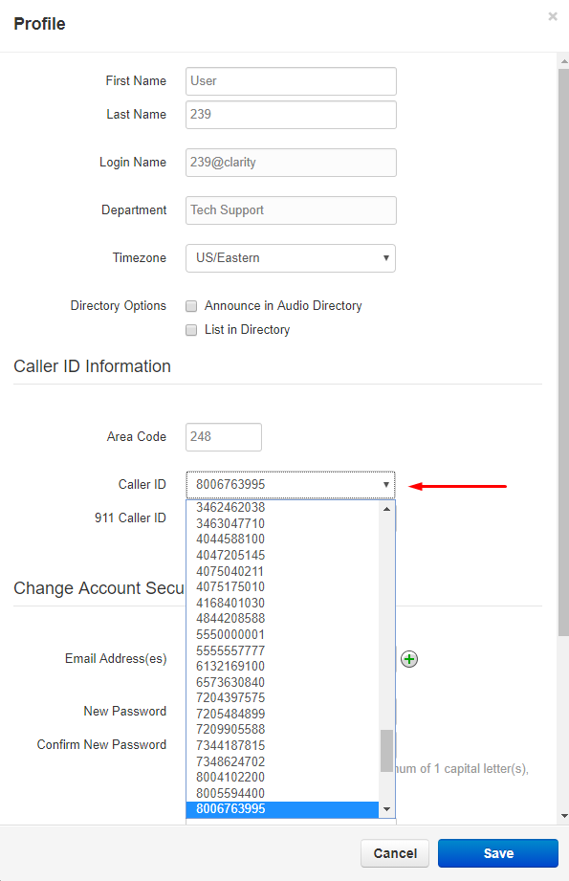
- Click Save.

Technical Assistance
•Please give our technical support department a call at 800-676-3995 with any questions, comments, or concerns regarding the phone system.
•Also, feel free to send us an email at: support@clarityvoice.com
•Our hours are Monday-Friday from 8 am –9 pm EST.
•Thank you for being a valued customer!

